

**Third Increment Report**

**Fall 2016**

TEAM - 6

* Kona, Lakshmi Nikitha – 22
* Ramesh, Sibi Chakravarthy – 45
* Natesan Arumugam, Bharath Kumar – 37
* Natarajan, Balaji - 36

**Table of Contents**

I. Introduction 3

II. Project Goals and Objectives 3

III. Project Plan 4

IV. Third Increment Report 8

# Introduction

Share up is a multi-platform application which saves the lot of bucks you spend in buying grocery items by searching for the cheaper and precise deals, for the people who want to shop together. Most of the groceries people tend to buy will probably be similar. So, if they buy those things in bulk they are likely to save a lot of money. They likely to face problems in sharing household expenses due to lack of understanding. To overcome these problems, we planned to create this application which significantly overcomes the above-mentioned problems in an efficient way. Each person who signs up has the credentials to create a group and add members to it. Each group will have a shopping list which any member can access and modify. So, for all the common things you can find cheaper deals, as our idea is to find one in bulk. The unnecessary portion which is yet to be bought can be shared with other members of any group by posting in a common forum visible to all other users who can contact the user to buy. The application also contains features to keep track of the money people owe each other, their monthly expenses and prediction of monthly as well as yearly expenses.

# Project Goal and Objectives

## Overall goal

The goal of this project is to create an android application which is useful for people living together in shared rooms/apartments for spending money smartly and share wisely.

## Objectives

* To reduce cost of buying items by smart spending feature.
* To get price of grocery items using API call(s).
* To provide common shopping list for all the members in a group.
* To test the application before deploying to uncover bugs.

## Specific Features

* Smart spending feature - which finds match for the required product with required quantity.
* Shopping list - which contains things that need to be purchased soon.
* Expense Manager - to manage bills and shared expenses among roommates.
* Common forum for sharing the product to be bought (quantities specified by the hosting group).
* Scanning items with barcode plugin.

## Significance

Smart spending and sharing will change the way people spend for buying grocery items and manage their expenses. There may be many applications which offer similar features, but this application performs these tasks in a single user interactive application.

# Project Plan

## Stories(Issues)

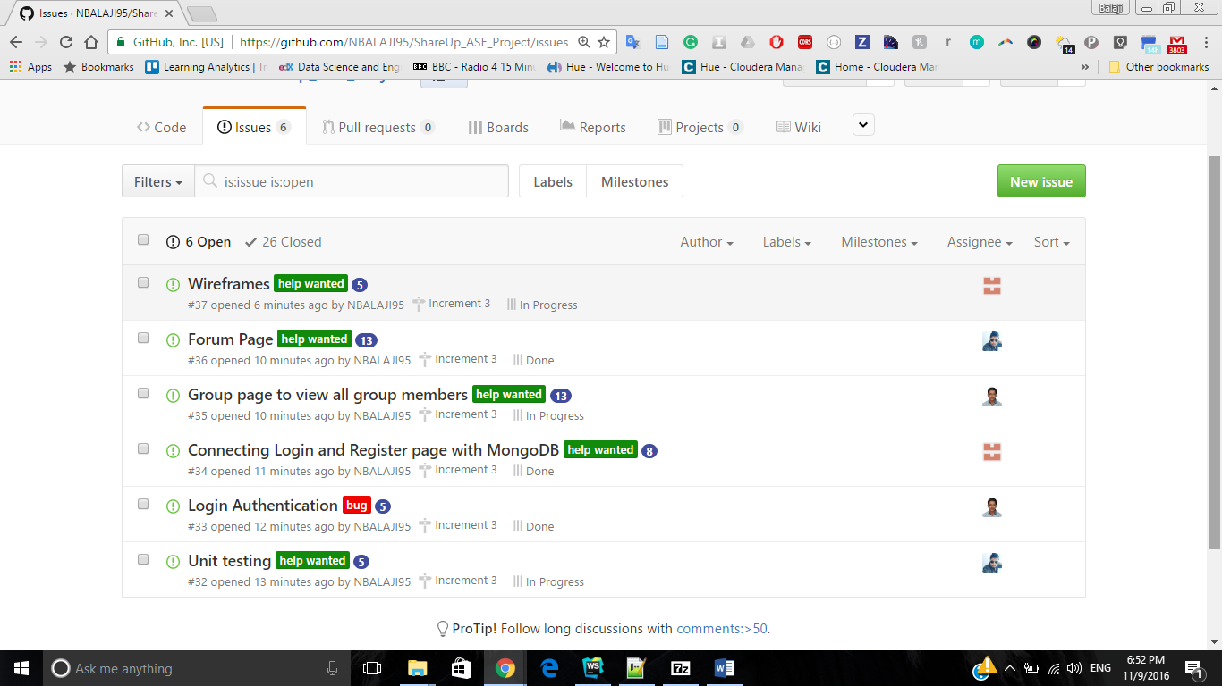

## Project Timelines

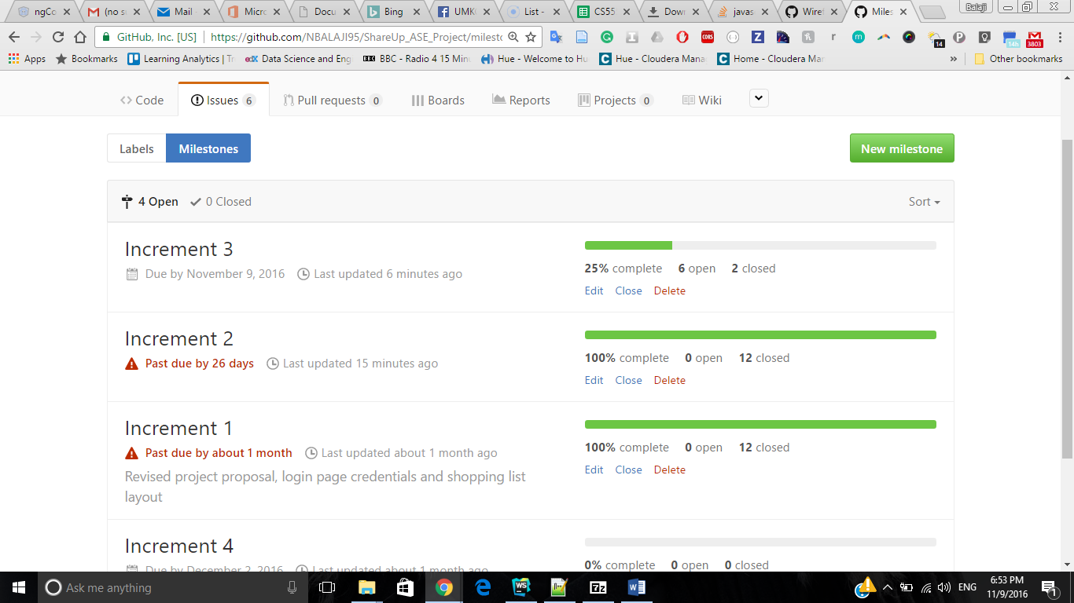

## Task Responsibility



## Burndown Chart

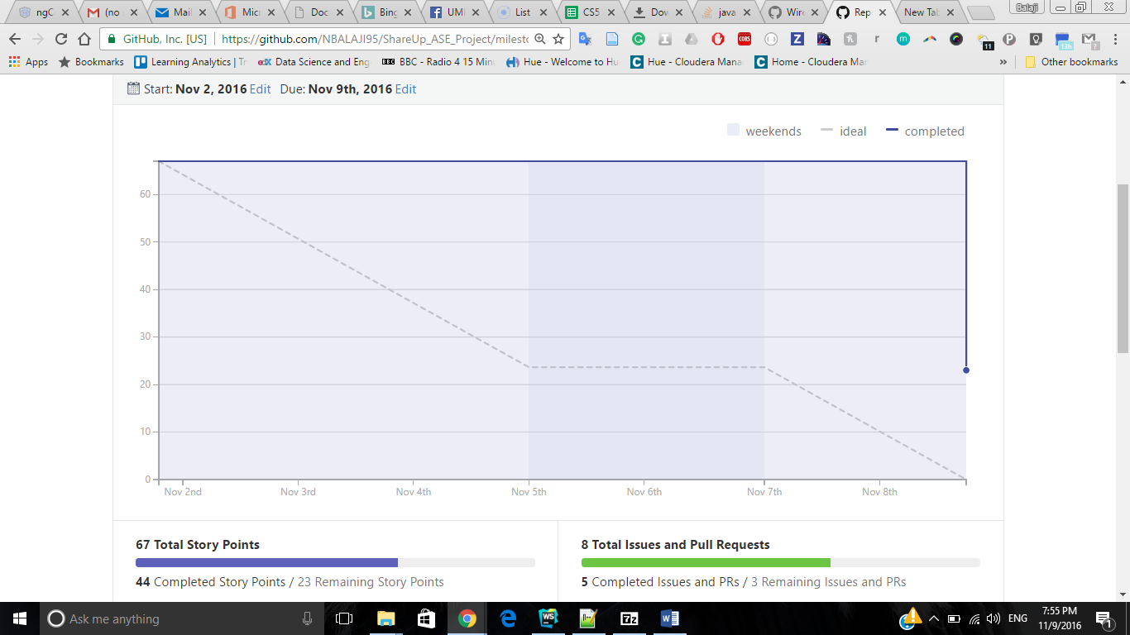

## Board

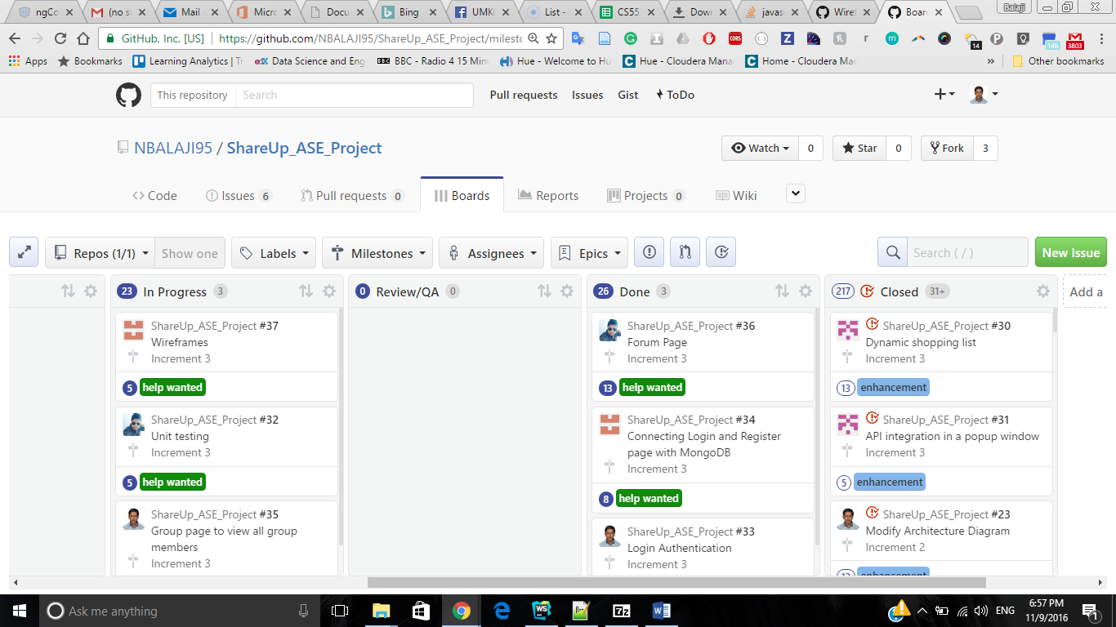

# Third Increment Report

Existing Services/REST API

Walmart API.

## Detail Design of Features (using tools) Wireframes

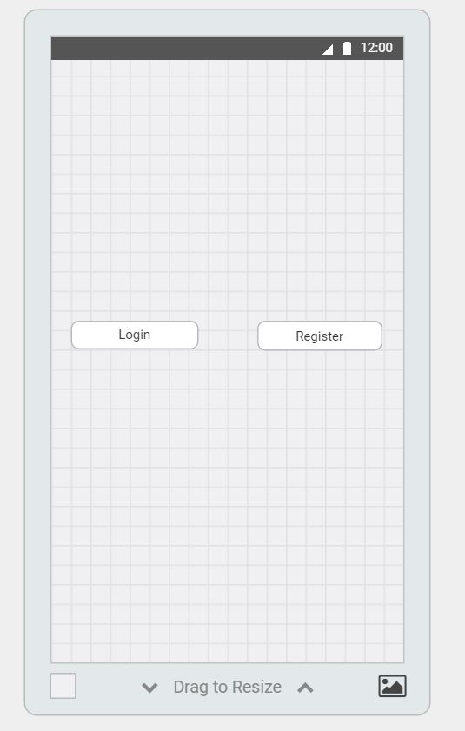

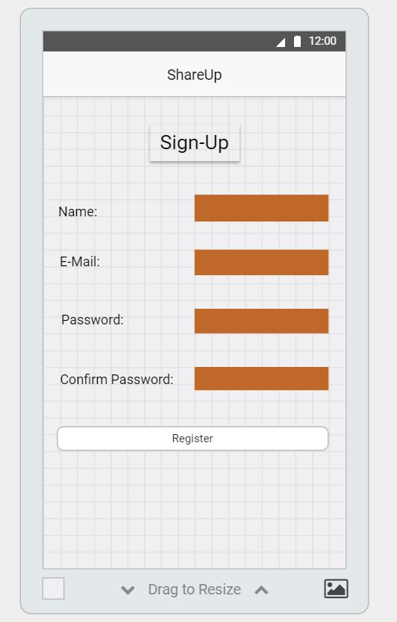

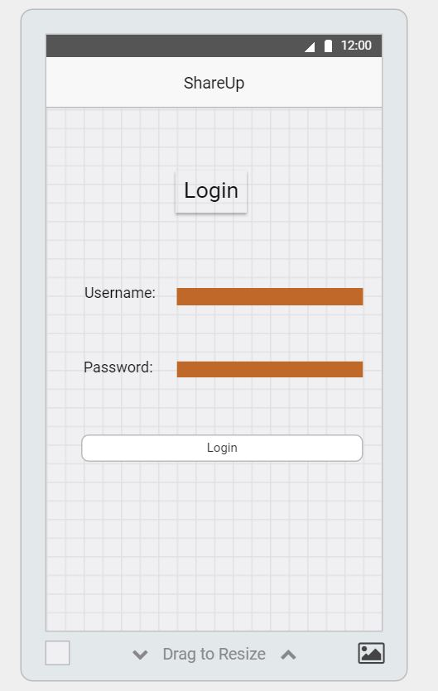

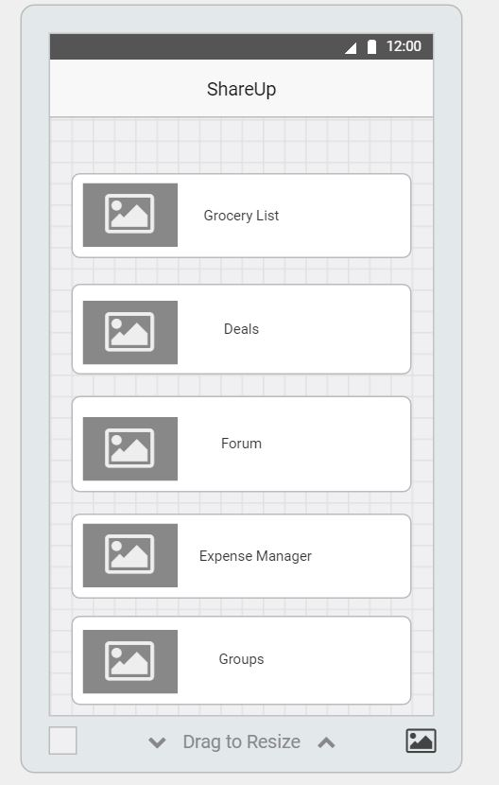

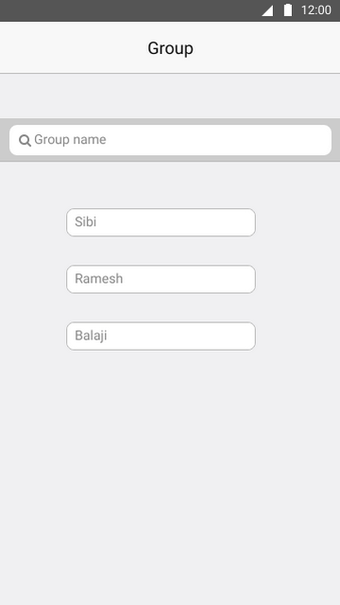

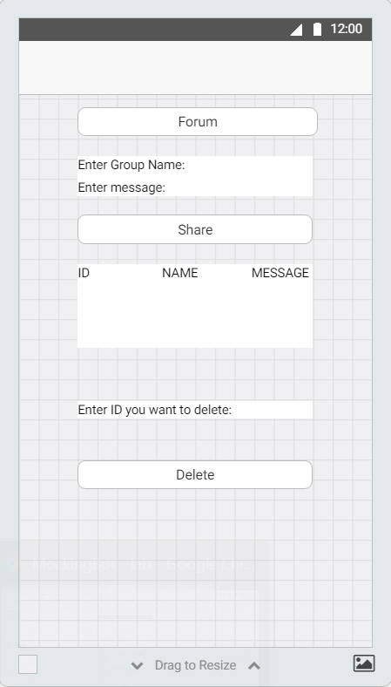

UML Class diagram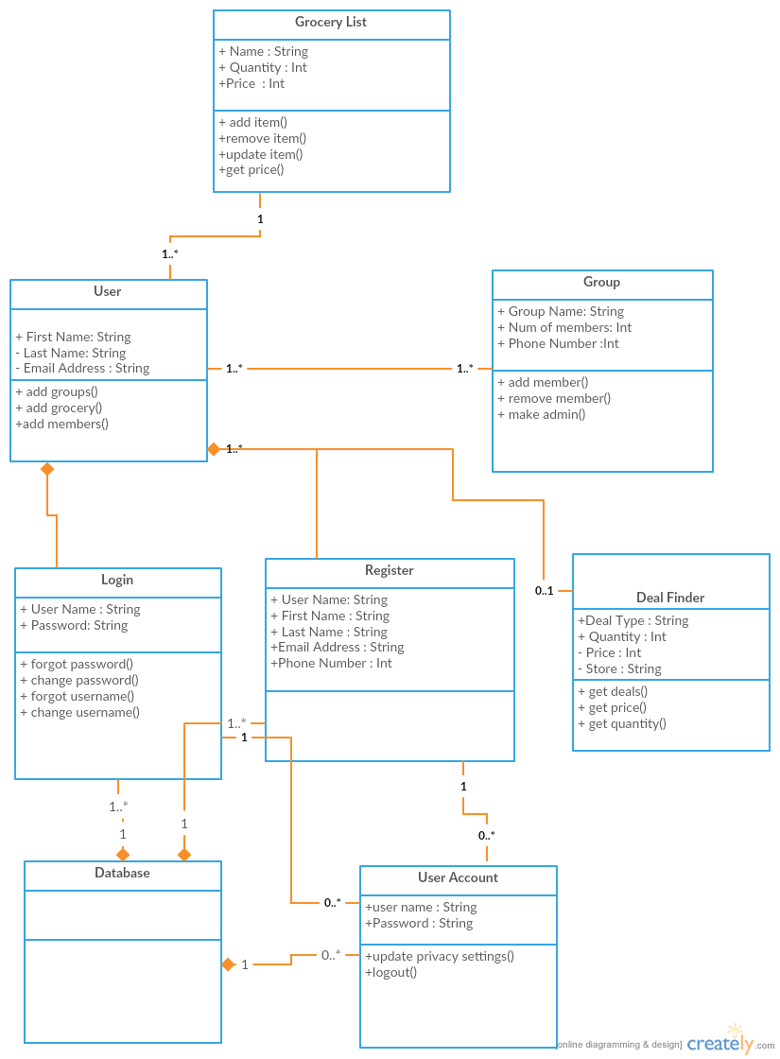

## Sequence Diagram

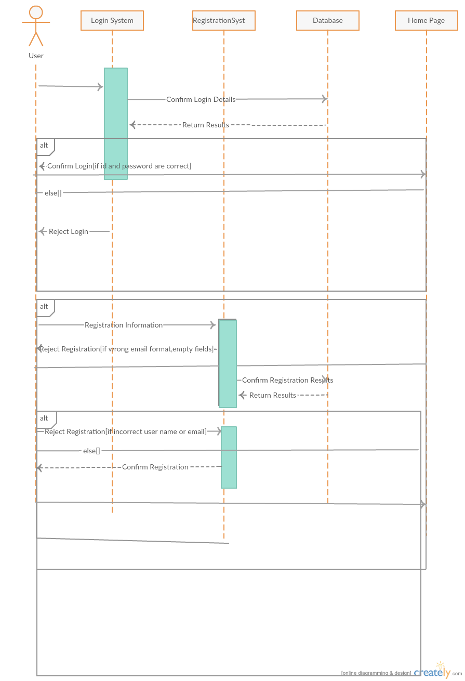

## Architecture Diagram

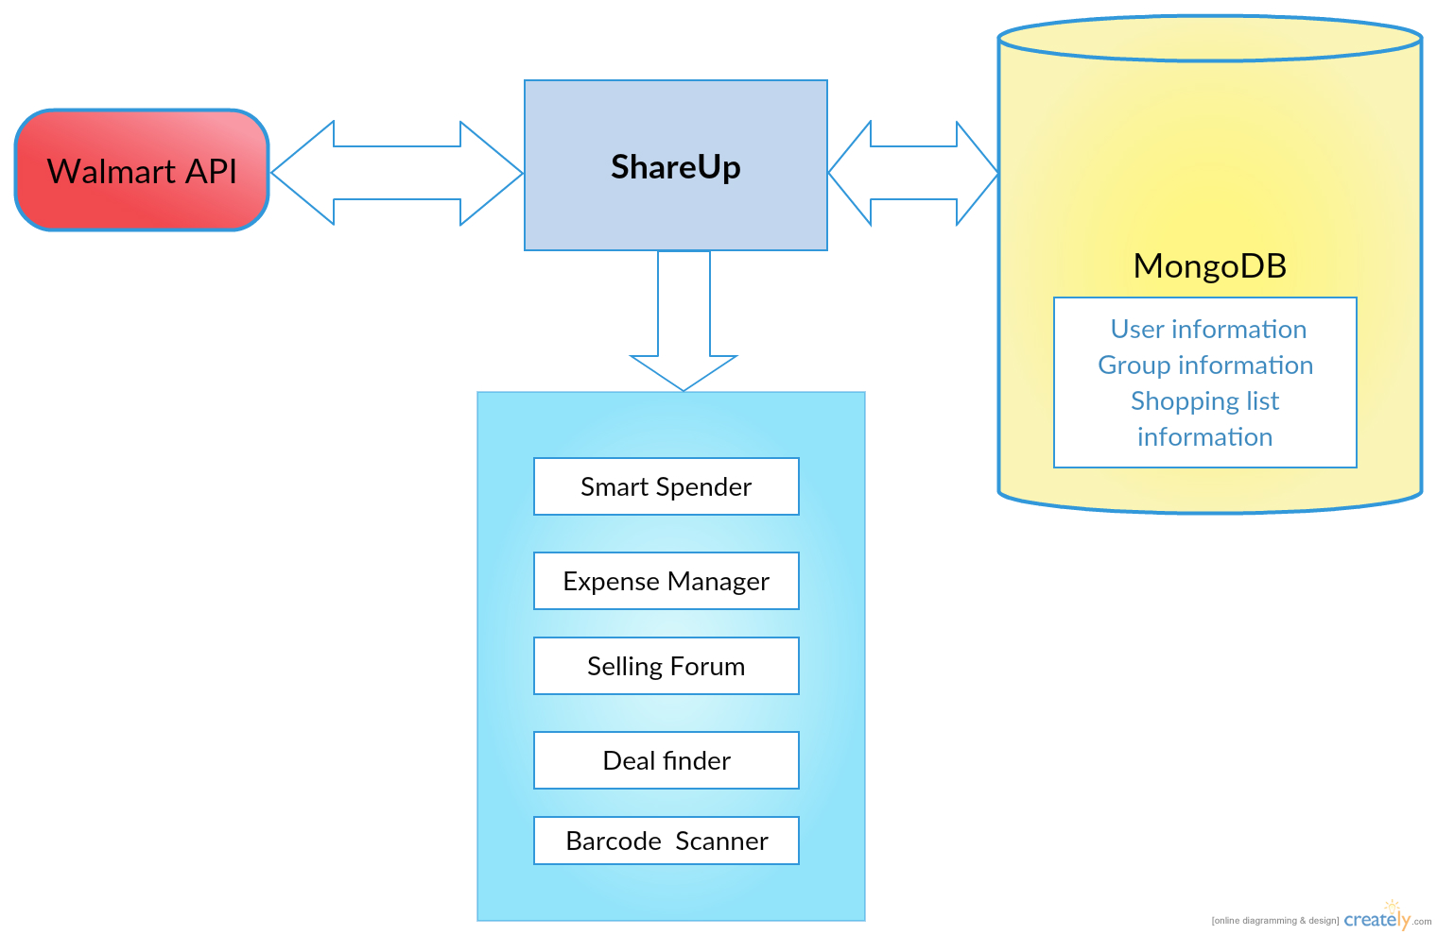

## Use Case Diagram

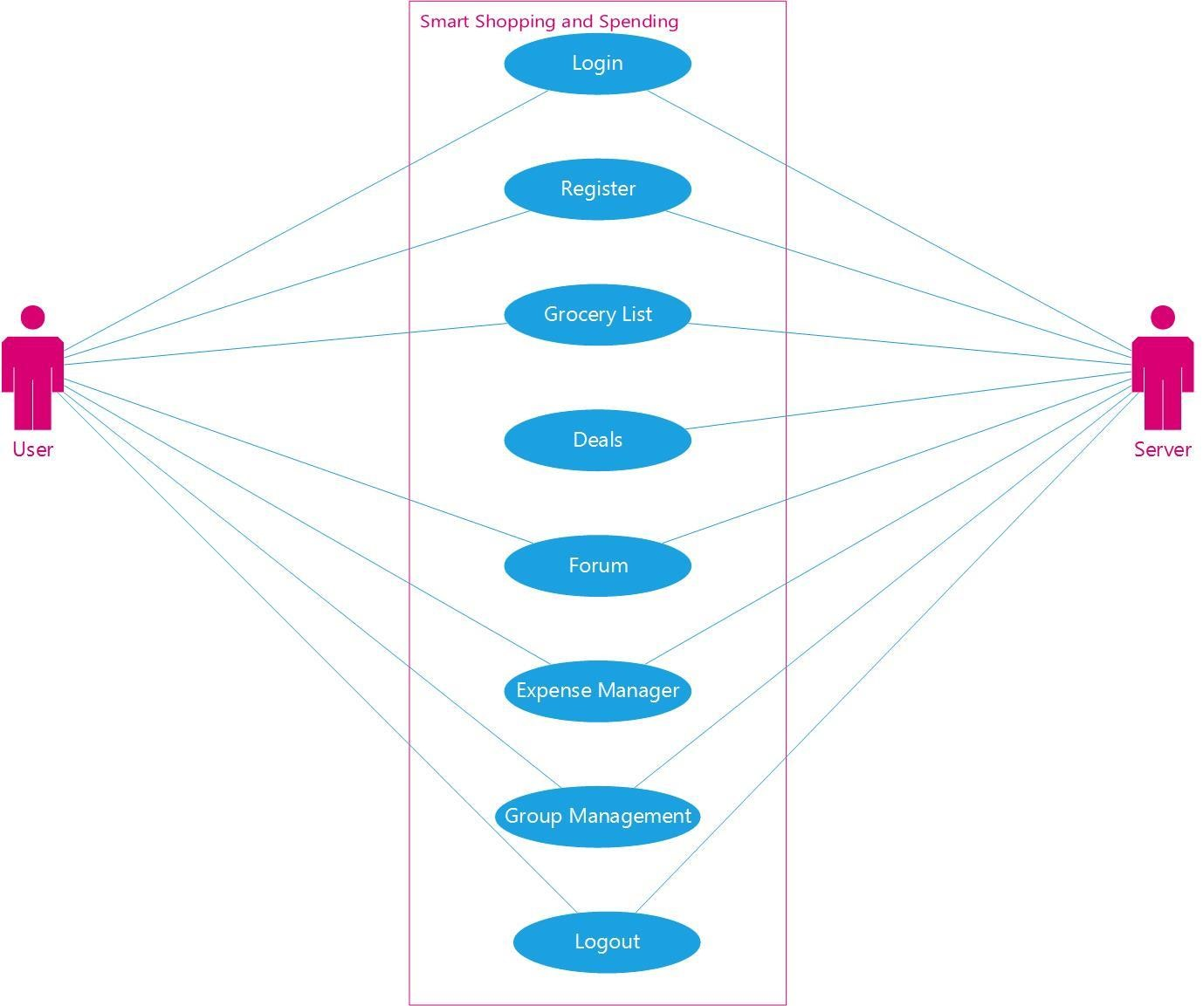

Implementation screenshot

**Android:**

We have login and registration pages where a mongo DB is connected at the back end.

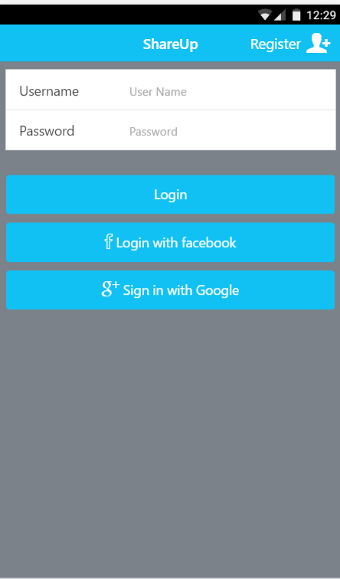

As the user hasn’t registered he will be redirected to the register page and then all the details are entered

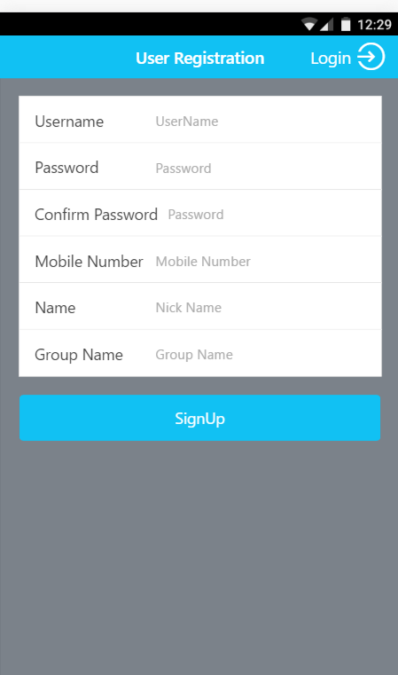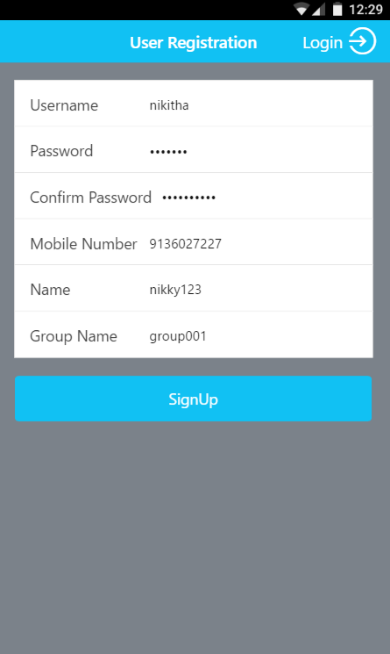

After all the details are entered the users nickname is displayed as a pop up . And then the mongo db screenshot has

been displayed below.

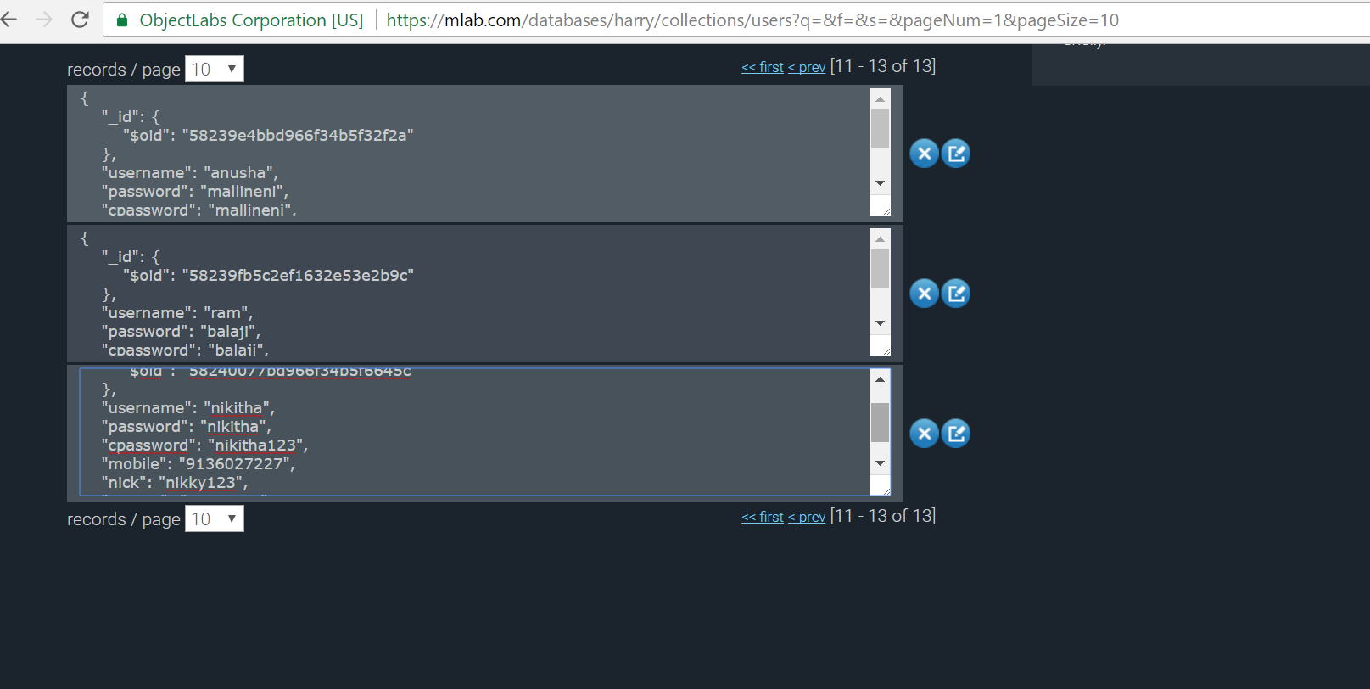

After then the user is redirected to login Page and after entering the details he will be redirected to the home page

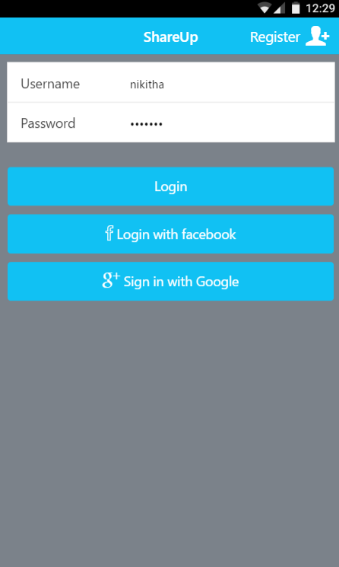

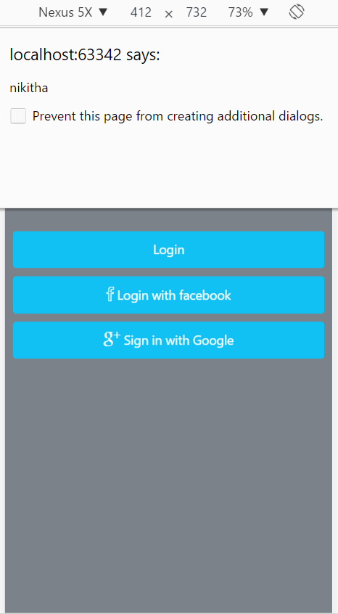

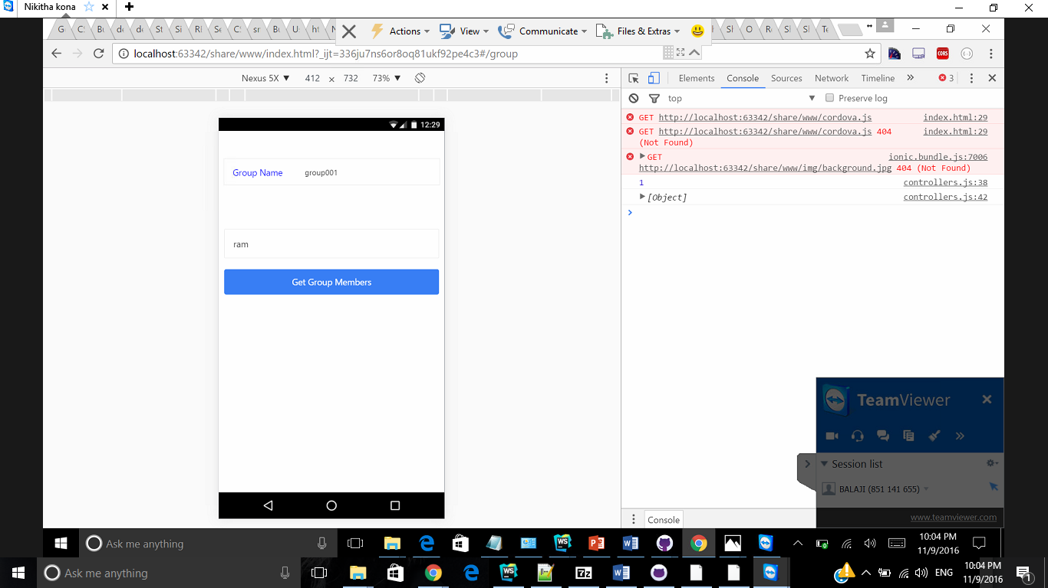

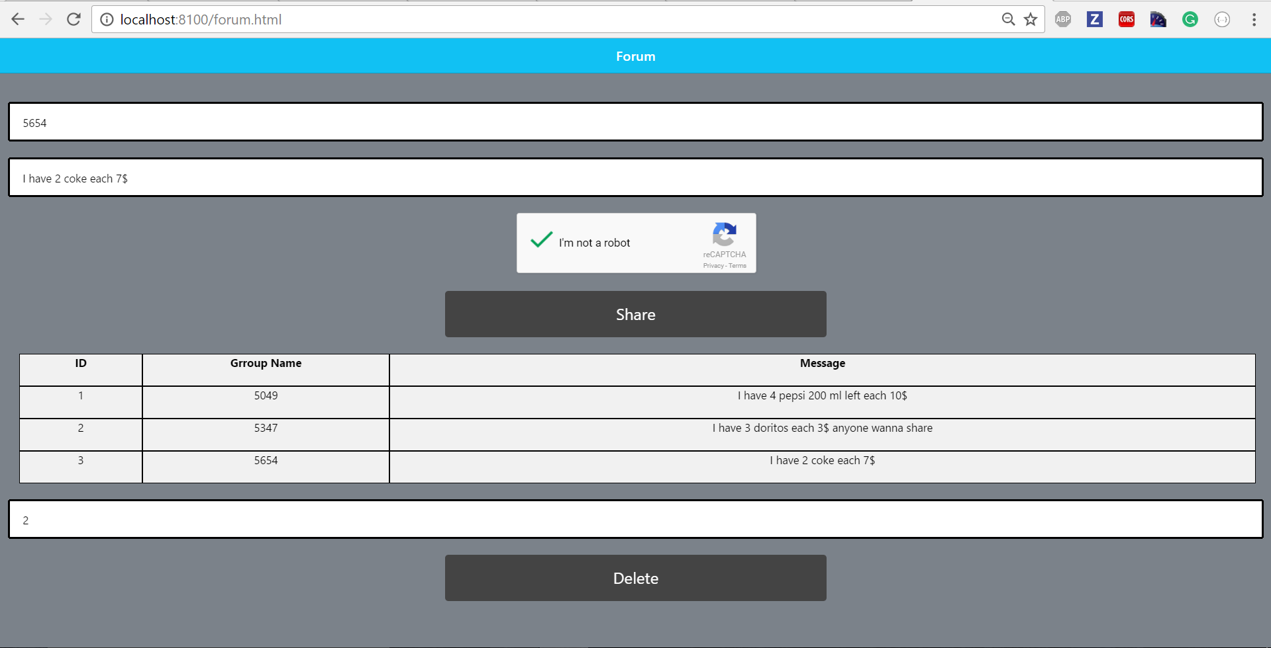

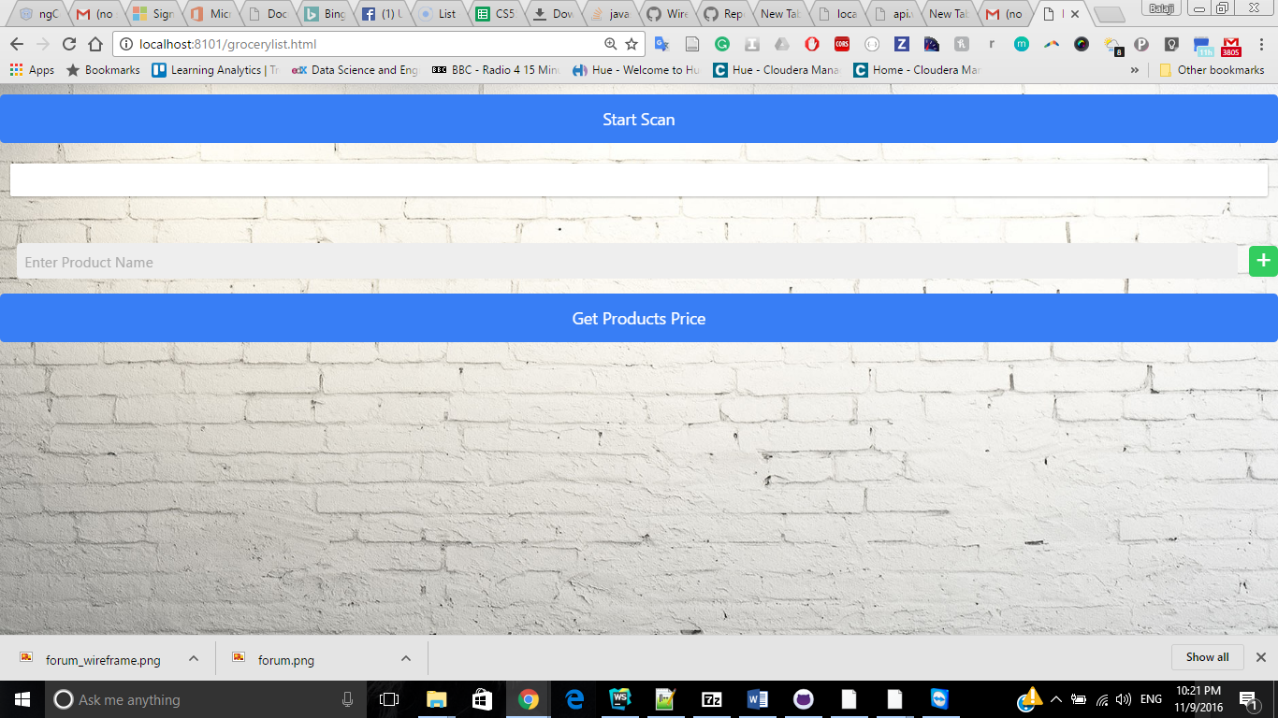

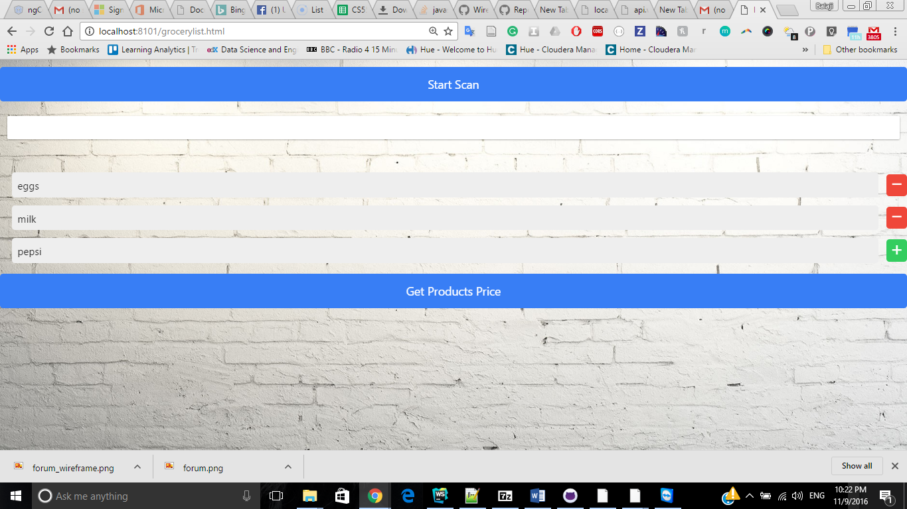

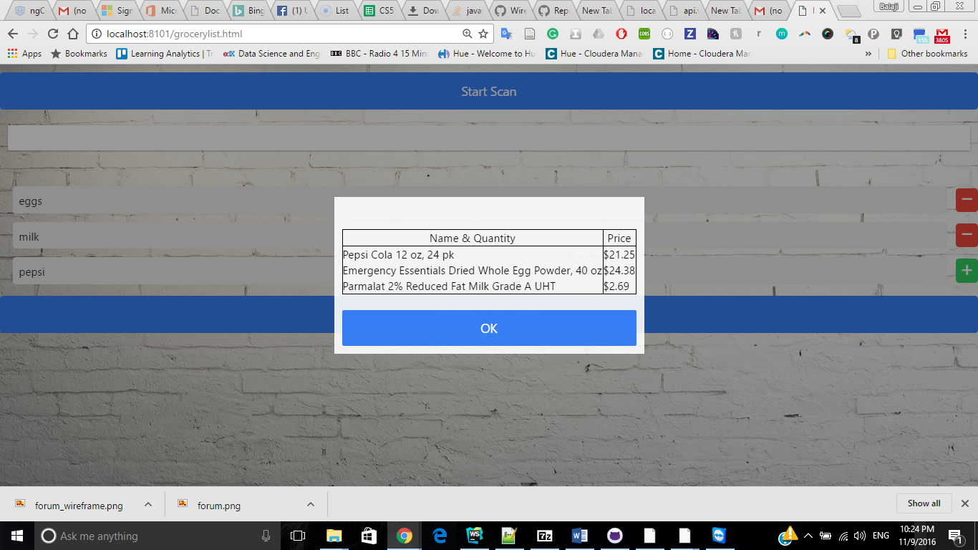

**Project Management**

## Implementation status report

**Technology Used:** Ionic, HTML, CSS, JS, Walmart API and Angular JS.

**Work Completed**

* Login, Registration and home page updating
* Shopping list update with Product price obtained from Walmart API
* Barcode reader plugin to scan items
* Created group template

**Contribution:**

* Balaji Natarajan – 25%
* Bharath Kumar A – 25%
* Sibi Chakravarthy Ramesh – 25%
* Nikitha Kona – 25%

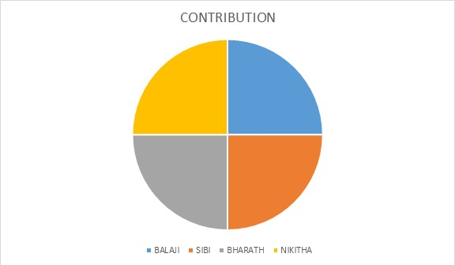

Bibliography

<http://ionic.io/developers><http://creately.com/><https://mockingbot.com/>

<http://www.supermarketapi.com/Default.aspx>